AWS Day 8:

SageMaker new version:

SageMaker Studio is different from Sagemaker notebook

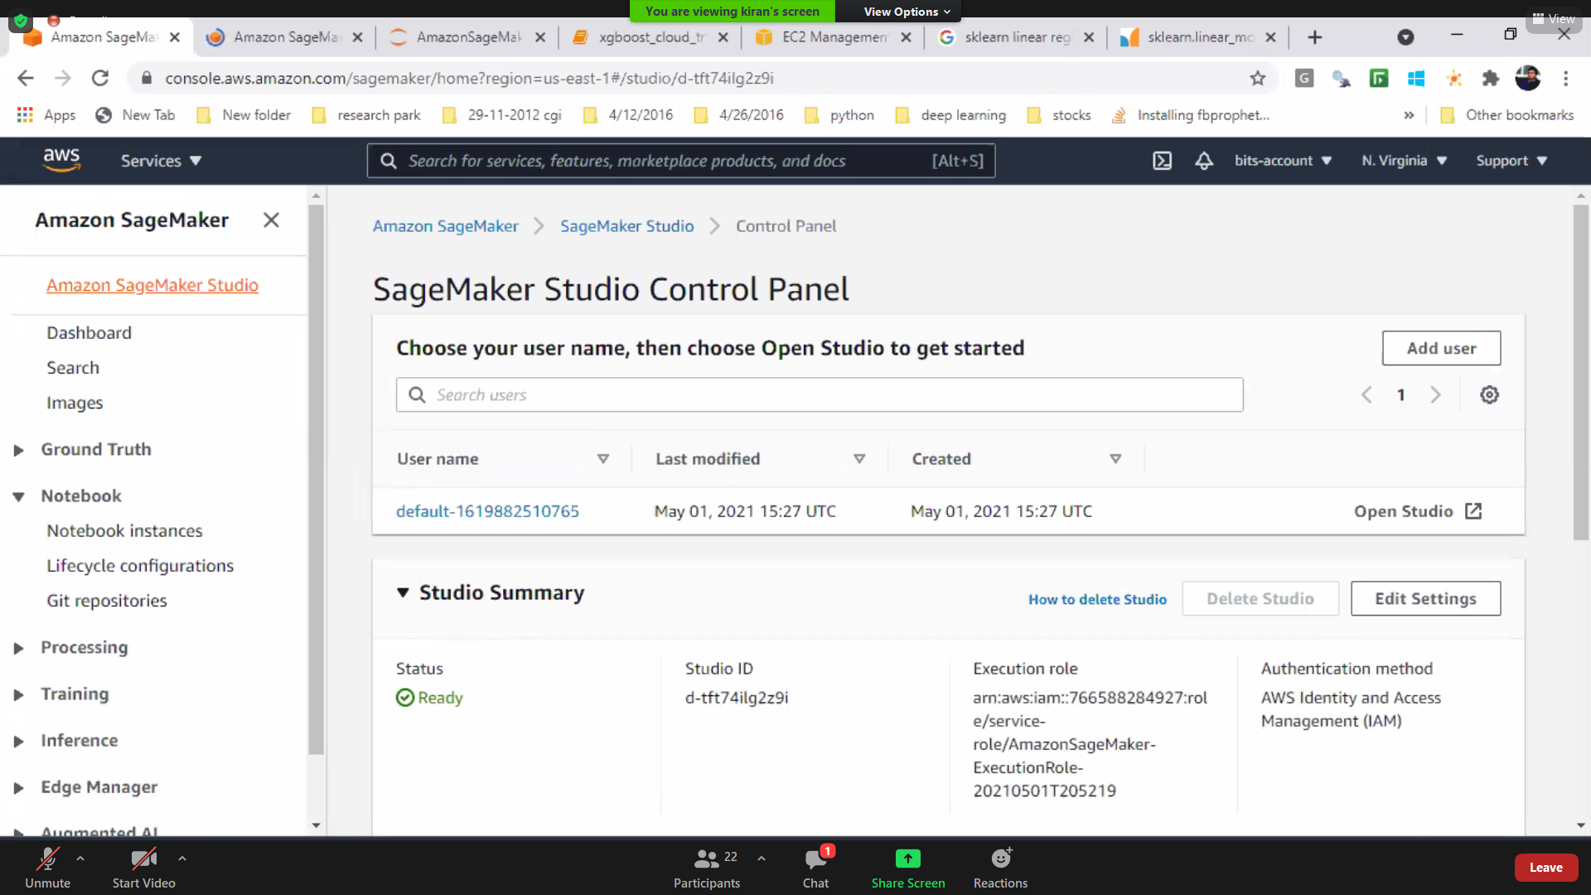

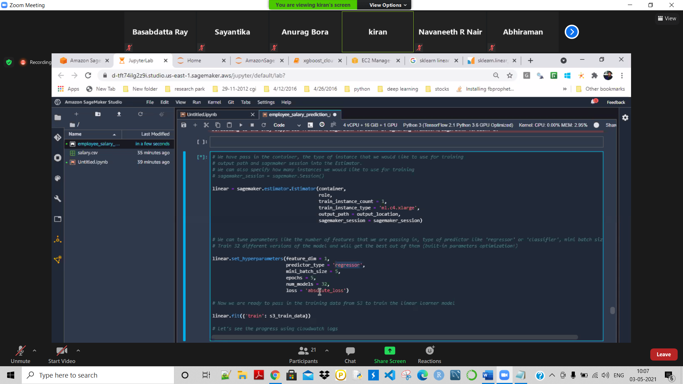

Case study:

Casestudy 8: build a classification model with linear_linear algorithm of sagemaker….